# Unit 3 Organising Ideas; Writing an Introduction

**Getting Taking Organising Linking ideas notes ideas ideas**

**Referencing Academic**

**style**

**Writing**

**Revising a final draft**

**The writing process**

## Session 1

*In this session you will learn how to do the following:*

* Structure an academic essay
* Make an essay plan to help put ideas together

**Activity 1: Structuring an academic essay**

1. *Use the words and phrases from the box to complete the gaps. (You can use a word more than once)*

main ideas and argument

conclusion

what you have said so far

purpose

illustrations and examples

introduction

body

order and connect

main idea

topic

The structure of most academic essays is straightforward. They have an

, a and a .

The introduction informs the readers about the and

of your essay using a thesis statement. The is the backbone of your essay where you present your . Each paragraph contains a which you then support with

. You should your paragraphs to show the progression of your ideas and lead smoothly to your .

Academic essays are fairly long pieces of writing. This means that in the

, you need to remind your readers . Then you need to wrap it all up convincingly and show you have achieved the

of your essay.

1. *Study the following diagram. Can you now connect your knowledge on the structure of an essay with this one?*

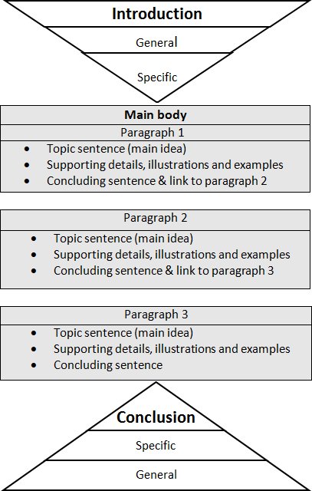

## Activity 2: How do I plan an academic essay?

When you write an essay, do you make a plan? Never / sometimes / always?

1. *Read the text and study the examples to find out about how to make a plan for an essay.*

The key to a good essay or any piece of academic writing is a good plan. There is no best way to write a plan. Some students like to write a plan with bullet points*; others like to make a mind map*. The important point is that you need to organise your ideas by putting together the ideas that seem to belong to the same paragraph. You then need to decide on a logical order for your paragraphs.

1. *Below are two examples of a plan for an essay. The topic of the essay is*

*Teenage Depression*

*Look at both plans. Discuss in small groups:*

* 1. Which plan do you prefer? Why?
  2. Is there anything you could improve?

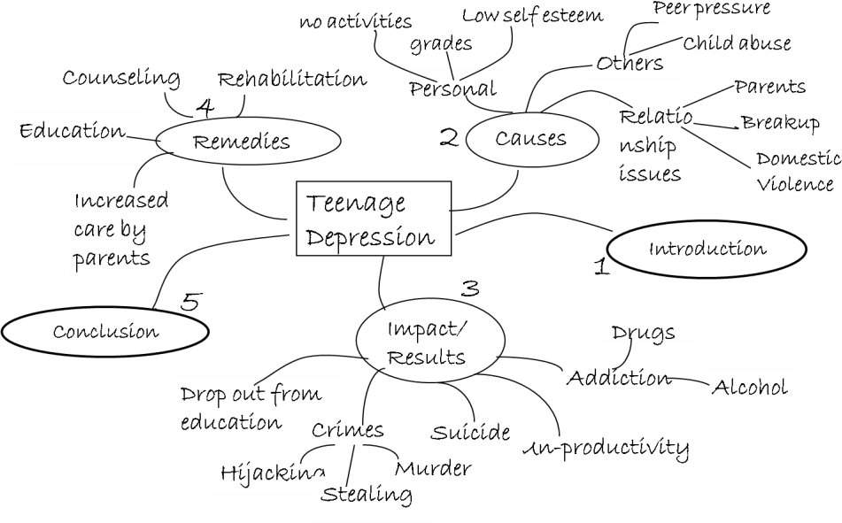

Plan 1 Mind map

Teenage Depression

Plan 2 numbered points

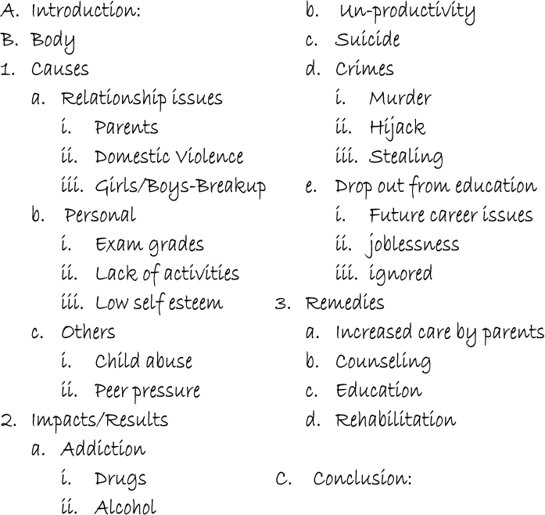

## Activity 3: Writing a plan for an essay

*Now go back to Activity 2 in Unit 1 Session 2, where you brainstormed ideas for an essay title. Now use your brainstorming notes to make a plan for the essay. You can use a mind map or bullet points. Write your plan below.*

Essay Plan

My essay title:

## Activity 4: Evaluating your plan for an essay

*Work with another pair. Look at another pair’s essay plan and*

*discuss:*

* What are the strengths and weaknesses of the plan?
* Are the ideas grouped effectively into paragraphs?
* Does the plan include an introduction and a conclusion?
* Are the paragraphs placed in a logical order?

## Extension: Developing academic vocabulary

Here are some useful academic words you are meeting in the units.

1. *Find them in the word search.*
2. *Check their meaning in a dictionary.*

analyse ~~identify~~ assessment major concept process

data research

definition specific

|  |  |  |  |  |  |  |  |  |  |
| --- | --- | --- | --- | --- | --- | --- | --- | --- | --- |
| t | s | r | h | d | m | s | a | w | n |
| s | n | g | e | a | a | n | i | o | f |
| p | i | e | j | s | a | t | i | e | t |
| e | r | o | m | l | e | t | a | p | s |
| c | r | o | y | s | i | a | e | d | z |
| i | t | s | c | n | s | c | r | b | v |
| f | e | o | i | e | n | e | m | c | r |
| i | a | f | h | o | s | r | s | f | h |
| c | e | c | c | a | n | s | g | s | m |
| d | i | d | e | n | t | i | f | y | a |

1. *Choose five of these words to make sentences which clearly show the meaning of the word.*



1.

2.

3.

4.

5.

## Home task

* 1. Portfolio task

  *Use the feedback* you received in Activity 4 to revise and improve your plan. Put your completed plan in your portfolio.*

# Unit 3 Organising Ideas; Writing an Introduction

**Getting Taking Organising Linking ideas notes ideas ideas**

**Referencing Academic**

**style**

**Writing**

**Revising a final draft**

**The writing process**

## Session 2

*In this session you will learn how to do the following:*

* Write an introduction
* Formulate a thesis statement for an essay

**Activity 1: Writing an introduction – what should you include? ** A good introduction is really important for generating the reader’s interest in what you are going to say and showing the topic and focus of your essay. So, what elements should you include in your introduction and how should you order them?

1. *Complete the diagram for writing an effective introduction using the elements in the box below*

More specific information related to the essay title

General background information introducing the topic

The organisation of your essay

The focus and purpose of your essay

**specific**

**general**

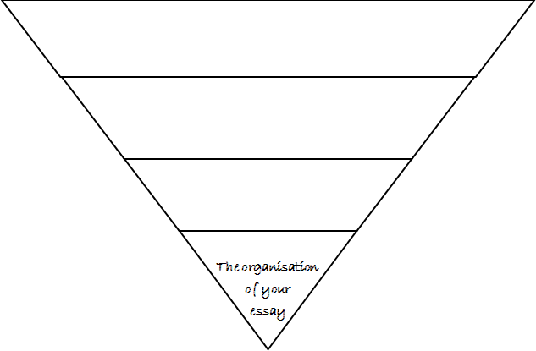

**Introduction: contents**

**and structure**

1. *Look at the introduction of the example essay in Appendix 1 to check your answer.*

**Study Tip**

In your introduction you can *also:* give definitions of key terms, explain the significance of the topic and explain the limits of the scope of your essay.

1. *Read the following extracts from some introductions. Match the extracts to the features of the introduction they cover. Work with a partner.*
   1. The purpose of this paper is to explore what Bangladeshi students think about the roles of English and Bangla in their university studies.
   2. Domestic violence is an abusive behavioural pattern shown by one partner to another in a relationship of love or marriage.
   3. The first part of the paper orients the reader with the present context of river erosion in Bangladesh. The second part takes on board the suffering caused by river erosion, while the third part suggests how to minimise the risk of river erosion.
   4. Even though a lot has been said about the role of the media in monitoring elections, little has been said about the importance of monitoring the media itself during election; in other words, about ‘watching the watchdog’.

*Example:*

1. – the purpose and focus of the essay

## Activity 2: Thesis statements: what are they?



A thesis statement is one of the most important elements of any successful essay.

1. *Briefly discuss in pairs:*
   1. Have you heard the term ‘thesis statement’ before?
   2. If so, what does it mean?
2. *Read the text and note down the features of a thesis statement.*

An important part of an introduction is the thesis statement. The thesis statement states the main idea or focus of your essay. It must not be too general or too specific. It must not be just a piece of information or a general truth. A thesis statement should precisely and accurately state the theme and message of your essay. It should indicate the flow and direction of the discussion. The thesis can remain implied or be stated precisely.

*Features:*

*1.*

*2.*

*3.*

*4.*

1. *Read the two thesis statements below for an essay: “HSC examination result and opportunity for higher education”. Which is the most effective?*
   1. While the increased percentage of passes in the HSC examination in recent years has pleased the government, the insufficient number of places for tertiary education has made the students worried about their higher education opportunities.
   2. The percentage of passes in the HSC examination in recent years has increased in Bangladesh.

## Activity 3: Is it a good thesis statement?

*Evaluate the following thesis statements. Redraft, if necessary, to make them more effective. Share your answers with the rest of the class.*

* + 1. Essay title: The Role of the Mother in Children’s Education

Thesis statement: Mother not only takes care of family affairs but also contributes considerably in the improvement of aptitude for learning among the children.

* + 1. ET: Prevention for Drug Addiction

TS: The government has taken initiatives to control drug addiction in recent years.

## Activity 4: Can you write an introduction with a thesis statement?

A student, Abid, is writing an essay on:

Impact of global warming on developing countries like Bangladesh

He has made some notes to help him with his introduction:

* Contributes less in GW but suffers the most
* Economy affected
* Inundation or flood
* Damage of crops & loss of livestock
* Loss of land areas
* Health hazards
* Condensed & unhygienic habitat in highlands
* Environment pollution – outbreak of diseases

1. *Use Abid’s notes to write an introduction for the essay. Remember to structure your introduction appropriately and include a strong thesis statement.*
2. *Work with a partner. Evaluate each other’s introduction. Does your partner’s introduction have a clear thesis statement?*

## Extension: Introductions and thesis statements

1. *Look at the introduction of the example essay in Appendix 1. Find the thesis statement and underline it. Check your response with the class.*
2. *Can you identify the more effective thesis statement from the following options?*
   1. Manik Bandopadhya’s *Putul Nacher Itikatha* is a great Bengali novel.
   2. Manik Bandopadhya’s *Putul Nacher Itikatha* upholds through its characters’ helplessness the existential crisis of human being.
3. An effective essay requires some qualities such as cohesion and coherence for the purpose of linking ideas and maintaining unity.
4. To write an effective essay students need to be careful.
5. *Write a thesis statement for an essay on the following topics:*
   1. Consequences of child trafficking
   2. The importance of good governance for economic development

## Home task

* + 1. Critical reflection

*Think back on what you have learnt in this unit and reflect on the experience.*

* + - 1. Do you think that you are now familiar with the different purposes of writing an essay?
      2. Can you make an effective plan for an essay?
      3. Can you now write an introduction with a thesis statement?
    1. Portfolio task

*Formulate a thesis statement and write the introduction for the essay plan you made in Unit 3, Session 1, Activity 3. Put your completed introduction in your portfolio.*

* + 1. New vocabulary

*Use your dictionary to search the meaning of the following words which you will encounter in the next unit and write in the table.*

|  |  |
| --- | --- |
| *Words* | *Meaning* |
| civic |  |
| emission |  |
| genome |  |
| hydrologically |  |
| replicate |  |
| unprecedented |  |